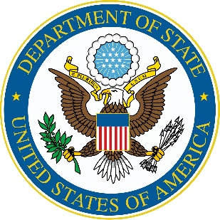
English Teaching Mentor Program 2023

PROGRAM APPLICATION
DEADLINE: December 10, 2022
Name
(As listed on passport)
 | Given Name | (Middle Name) |  | Family Name
Date of Birth
Gender | ☐ Male ☐ Female
Country and City/District of Residence
Are you a citizen of Tajikistan? | ☐ Yes ☐ No |  | Will you be living in Tajikistan during the ETM program? |  | ☐ Yes ☐ No
Email Address
(Please use your own email address.)
Phone Number

Emergency phone number

Prior participation in the ETM program Date and year attended

Prior participation in other U.S. Government Sponsored English Programs/ Date and year attended

Current place of work
Your degrees: (e.g. Bachelors, Master’s):
Your major field of study:
Are you a member of any English Teachers Association? If yes, please indicate.
Teaching experience (years):

What do you do? (Check as many boxes as apply)
☐ Administrator
☐ Principal
☐ Curriculum Developer
☐ University Professor/Lecturer
☐ Ministry of Education Official
☐ In-service Teacher (Primary)
☐ In-service Teacher (Secondary)
☐ Pre-service Teacher
☐ English Access Microscholarship Program Teacher
☐ English Access Microscholarship Program Administrator
☐ Other _____________________
☐ Tutor

Please assess your present English language proficiency. (select one)
Written English | ☐ Excellent ☐ Good ☐ Fair
Spoken English | ☐ Excellent ☐ Good ☐ Fair
Reading English | ☐ Excellent ☐ Good ☐ Fair

Statement of Purpose: Please explain why you are applying for this program in less than 300 words. Please include your plan to share the results of your mentorship program with other teachers at your school upon its conclusion.

Recommendation letter: Please attach a letter of support from your current school administrator indicating your eligibility as well as the administration’s agreement for your participation in this program.
Submit the application to: EnglishProgramsDushanbe@state.gov Applications deadline: December 10, 2022
Tel: +992-37-229-2316

Tel: +992-37-229-2316

